Theism -- from the Greek “theos” -- In the strictest sense the term can be defined as: "the belief in a God or gods of any kind." This would include:

Animism, Polytheism, Henotheism,

Pantheism, Deism, Monotheism

Animism – is the belief in the universal presence of spiritual beings "gods", which control the material universe and man's life.

“The bogie man god”

Polytheism – is the belief in many gods and the worship of them. They dwell apart in a spiritual realm above the earth, though they may be symbolized by images.

“Gods, gods and more gods”

Henotheism – is the belief in a hierarchy of gods. The worship of one God combined with the belief in the existence of many lesser gods.

“Big gods and little gods”

Pantheism – is the belief that "all is God and God is all". Everything that exists is a form or manifestation of God.
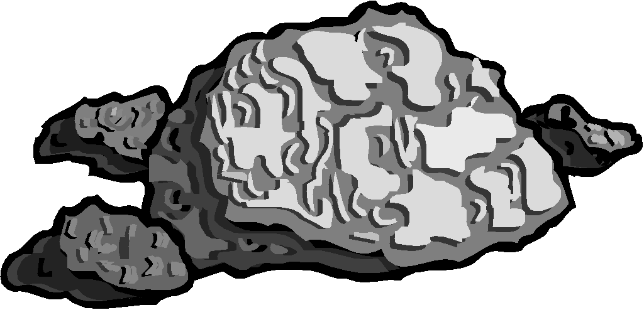
“God is a rock”

The term first used by the English deist, John Toland (1670-1722), who said: "God is the mind or soul of the Universe". The goal or aim of religion is to get in harmony with nature or in tune with the universe. This is accomplished by saying ones "mantra". Pantheists deny the transcendence of God, that He is distinct from His creation. They do except the immanence of God, that God is near, God is in us, or God is us.

Deism – is the belief in a personal, but non-relational Supreme Being. God is a person, but is non-personal. He is indifferent and inactive in the world.

“The cosmic clockmaker”

“The God that could care less”

Deism denotes a certain movement of rational thought which was active chiefly in England from the mid-17th century to the mid-18th century. Lord Herbert of Cherbury (1583-1648) is called the father of Deism. Deist believed that God created the world and like a clock wound it up and let it go. God made the world and does not “monkey” with it. God does not intervene in the world. He is a person but is non-personal. He does not answer prayers. He is indifferent and inactive in the world. The world sustains itself. Deism denies that God is immanent -- that He is near. They believed that man was still obligated to divine worship, ethical conduct, repentance of sins and to divine rewards and punishments, in this life and the one after. However, they denied the miracles of the Bible, the Trinity, that Jesus was God, and the resurrection of the body.

Agnosticism – is the belief in not knowing whether God exists or does not exists. It is a decision of non-decision, a commitment to being uncommitted.
Thomas Huxley invented the term agnostic at a meeting of the Metaphysical Society in 1869. The term was intended to cover the negative philosophical religious views of which he shared with Herbert Spencer". Robert Flint's Agnosticism, an elaborate refutation, pointed out that Skepticism would have been more accurate and suitable term. Some have been skeptical and pro-theistic, like Sir William Hamilton (1788-1856) and H.J. Mansel (1820-1871) whose position was one of "denying that God can be known while affirming that God should be believed in". (Flint, op. cit., p. 604)

There are Two Types of Agnostics - Soft-core and Hard-core:

Agnosticism #1 - the belief that says, "God may exist, I just do not know if he exists".

“The great perhaps”

Agnosticism #2 - the belief that says, "God may exist, but I cannot know if he exists".
(The natural man cannot know God outside of special revelation).

“The unknowable God”
Atheism – is the belief in the denial of the existence of any God or gods of any kind.

“The God who is not there”
The supernatural and immorality are myths. Nature represents all possibilities and actualities. The existence of all things can be explained naturally rather than supernaturally. Man is the measure of all things. Man is autonomous. Atheism comes wrapped in a variety of ideas such as rationalism, empiricism, materialism, existentialism, and secular and religious humanism.

There are Two Types of Atheism:

Muted/Practical Atheism – the belief that says, “I suspect that there is no God because there is no evidence of his existence”. He assumes God does not exist, and gets on with life The evidence for God’s existence is not convincing, nor important. He is unconcerned with the question of God’s existence. He lives as if there is no God, though he willingly confesses he has no proof to support atheism.

Militant Atheism, Antitheism -- the belief that says, “I know for certain that there is no God because there is evidence of his non-existence”. It is “the deliberate, definite, dogmatic denial of the existence of God”. He believes he has positive proof of the non-existence of any God or gods.

Monotheism is the belief in one God and no other God or gods.

“The One and Only”

Christian Monotheism is the belief in only One Trinitarian God.

“A God who is unique, personal, plural, spiritual, eternally self-existent, transcendent, immanent, omniscient, immutable, holy, loving Being, the Creator and Ruler of the entire universe and the judge of all mankind”2

In Contrast To:

Animism - He is Spirit, He is incorporeal, (He has no body or physical form)
Polytheism - There is only One God.
Henotheism - There are no other gods.
Pantheism - He is transcendent, He is completely distinct from His creation, He is above all, He is Great!
Deism - He is immanent, He permeates the entire universe, He is active in the world and in the affairs of men, He is a relational Being who cares, He is Good!
Agnosticism and Atheism - His existences can be known and He is knowable, He is communicable and revelatory.

MAKING A RATIONAL CASE FOR THE EXISTENCE OF GOD

Presenting a case using lines of argument, reasoning, evidence, and/or testimony.

ARGUMENT #1 - The Argument from First Cause (Cosmological Argument)

The evidence that every effect has a cause, every move has a mover. Logic demands that there must be a first cause - which is uncaused.
Cosmology is the study of the cosmos and its processes. This argument proceeds from the idea that the existence of motion implies ultimately a Prime Mover. Each effect has a cause adequate to produce it. There must be a first cause! Unless one believes that something comes from nothing, which is illogical, and irrational, then one must conclude that something is eternal and uncaused.

There are Only Two Possible Options:
- God
- Universe

One either says, “The universe (all material substance) is eternal, the universe caused itself or is uncaused” or “something greater (God) caused the universe”. Our system of logic demands that there must be a cause for the existence of the universe (God), or that the universe itself is eternal and uncaused.

There are Only Two Possible Groups (One Rational, the Other Irrational):

- Theists – are those who believe that God is eternal and is the first cause. Everything that exists can be explained supernaturally.

- Materialists – are those who believe that matter or energy is eternal and the first cause. Everything that exists can be explained naturally.

Materialists make an irrational case for the eternal nature of the universe and against the existence of God by making chance a force or cause for everything. Chance has become something.

Chance + Time = Everything

But What Is Chance?

Chance = Nothing

The Result is an
Nothing + Nobody = Everything
Absurd Formula:
“Chance has been transformed into a force of causal power, so that nothing is the cause of everything. What could be more irrational than that?" John MacArthur, The Battle for the Beginning, p. 41.

There is Only One Possible Rational Answer:

God Is The Great Uncaused Cause
The universe is an effect because it is not eternal and therefore needs a cause. The Scriptures tell us, "In the beginning God (cause) created the heavens and the earth (effect)". "God" a highly intelligent, self-conscience benevolent creator first caused the universe to come into existence. God was not caused but is eternal. God has no cause because He is self-existing, the eternal one. He is “Yahweh” – “I AM” “I EXIST”.

ARGUMENT #2 - The Argument from Design (Teleological Argument)

The evidence of order and design in nature indicates purpose and therefore a Designer.

From our observations of the universe (natural revelation) we see evidence of purpose and design. We see evidence of an infinite and all powerful and good Creator. “The heavens declare the glory of God…” (Psalm 19:1). “For since the creation of the world God’s invisible attributes, eternal power and divine nature have been clearly seen, being understand from what has been made…” (Romans 1:20) Order and design clearly points to an Orderly Designer. Purpose and design does not and cannot come out of chaos. Millions of examples of order and design exist, i.e.: the complexities of the human body - ears, eyes, blood, bones, muscles, cells, genetic code, etc. all existing in the just the right size and fashion, demonstrate that it was no accident of nature, but that it had purpose and a Creator.
"Common-sense logic suggests that every watch has a watch maker… It is natural to conclude that Someone infinitely powerful and infinitely intelligent made it all".

John MacArthur, The Battle for the Beginning, p. 37.

Materialists (Robert Dawkins) believe that blind physical forces (chance) mimic the effect of conscious purposeful design. “Do not confuse me with the facts/evidence I have already made up my mind”. The supernatural does not exist, only the natural. Therefore, evidence for the supernatural must be ignored or given a rational explanation no matter how irrational it may sound.

ARGUMENT #3 - The Moral Argument (Anthropological Argument)
The evidence of standards of morality, beauty, and truth points to a Greater Morality.

The argument proceeds from the idea that because there are standards in the world of relative beauty and truth, there must be somewhere an absolute standard to which all things must ultimately be compared. Because everyone possesses a sense of morality this proves that there is a Greater Morality.
"The existence of morality, an awareness of moral actions and relative "rightness" or “wrongness" of those actions, can only be explained if somewhere there exists an absolute standard and arbiter of moral actions".

Henry Morris, Much Infallible Proofs. Creation Life Publishers, 1974. p. 100-103.

People have a sense within them that they should be punished for doing wrong and rewarded for doing right. Where did this sense come from if it did not come from a greater moral being? Our sense of justice comes from a God who is just. Our sense of morality comes from a God who has standards of morality.

CLOSING ARGUMENT
Rational lines of reasoning demands that God is the first and uncaused cause, design gives evidence of a Designer and the existence of morality points to a Greater Morality.

The Result is a Rational Formula For The Existence of God:

First Cause + Design + Morality = GOD


GOD’S
EXISTENCE?

CASE CLOSED


THE NAMES OF GOD
Lord God

- el -- Strength, Mighty. The generic name for God throughout ancient Semitic languages.

- Elohim -- the Hebrew word for God. It has plural ending, but uses singular verbs. I.e.: "Gods was here". Theos is the Greek word for God.

- Yahweh -- “I AM”, Kurios, "LORD"
- Kurios is used throughout the Septuagint for Yahweh.
- Yahweh means “the self-existing, eternal One”; “I AM who/what I AM”; “He is”; “He is has sent me”. Yahweh has no potential. He is an actuality. He is what He is and that’s it. “I will be who/what I will be”. He “will be” to them (us) “what” His deeds will show Him “to be”.
- Yahweh is the Jewish national name for God. Yahweh is the only truly personal name of God, all others are descriptive expressions.
- Yahweh comes from the root “hayah” - to exist, be or become.

- Adonai -- Kurios, “Lord”, not capitalized; used throughout the Septuagint and English translations for Adonia
  - Adonia means “Sovereign Master”.
  - It occurs most frequently with the name Yahweh. It occurs less frequently with Elohim.
  - In the English versions it is translated “Lord GOD” to distinguish it from “the LORD God” which is “Yahweh Elohim”. “Eventually reverence for the divine name YHWH led to its being replaced by Adonai not only in oral reading but probably also in written copying of text”

    - El Shaddi -- "Almighty”, “Strong One” or “Strong God"
The "breasted God" - some have taken this to mean that God is feminine, but God is never used with feminine adjectives or verb forms. The title first appears in Genesis 17:1, where God first identifies Himself. It refers to Jesus in Revelation 1:8.

- El Elyon -- "the Most High God"
Genesis 14:18-20; Daniel 4:2; 5:18; / Hebrews 1:2; Matthew 28:18

- El Roi -- "the God who sees"
Genesis. 16:13 / Hebrews 4:13

- El Olam -- "the everlasting God"
Micah 5:2; John 1:1; Hebrews 13:8

- Yahweh Shalom -- "the LORD our peace"
Judges 6:23-24; Phil. 4:9; 2 Th. 3:16 / Col. 3:15
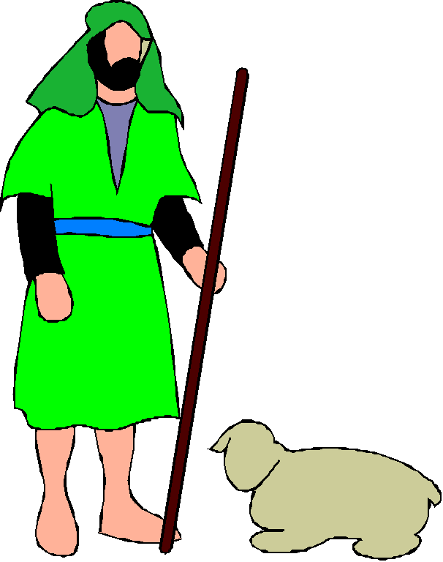
- Yahweh Raha -- "the LORD my shepherd"
Psalm 23:1 / John 10:14

- Yahweh Tsidkineu -- "the LORD our righteousness"
Jeremiah 23:6 / I Corinthians 1:30

- Yahweh Shammah -- "the LORD who is there"
Exodus 34:28

- Yahweh Jira -- “the LORD will provide”
Genesis 22:14; I Corinthians 10:1-4

- Yahweh Rapha -- “the LORD that heals”
Exodus 15:26 / Matthew 8:7

- Yahweh Nissi – “the LORD our banner”
Exodus 17:8-15


THE ATTRIBUTES OF GOD

ESSENTIAL ATTRIBUTES – Attributes That Makeup His Essences:

- Spirit -- "God is spirit…" (John 4:24).

- Incorporeal -- no body; "the spirit has not flesh and bone" (Lk. 24:39; Deut. 16:22).

- Invisible -- "And He is the image of the invisible God…." (Colossians 1:15) All images are false except for Christ.

- Alive -- "who has heard the voice of the living God" (Deut. 5:26; see also: Psalm 115:3-9) - God is not merely an idea; "You are the Christ, the Son of the living God" (Mt. 16:16); "My Father is working…" (John 5:17) - God is active; "the household of God, which is the church of the living God…" (I Timothy 3:15); Christ is called "the living one" (Revelation 1:18).

- A Person -- "I AM WHO I AM" (Exodus 3:14); "I am the LORD" (Isa. 45:5) - He is self-conscious. He is personal. He is a Father who has a Son. He has relationships and is relational. God is a relational being who communicates with other personal beings.

- Self-existent -- Yahweh - "He is" (Exodus 3:14); "In Him was life…." (John 1:4); "…the Father has life in Himself…" (5:26); “Jesus said to them…before Abraham was born I am" (8:58); "I am the first and the last, and the living One; and I was dead and behold I am alive forevermore…." (Revelation1:18).
- Immense -- "But will God indeed dwell on earth? Behold, heaven and the highest heaven cannot contain You…" (I Kings 8:27); God is not localized. He is infinite with regard to space. However, the Son is localized in some sense.

- Transcendent – “God is over and above all things, outside of time and space, completely distinct from the universe, and not to be confused with it in any way”.

- Immanent – “while remaining separate from it in being and essence, he permeates the entire universe”. God is near to each one of us. He is imminent.

- Eternal – God has no beginning and no end. "the name of the Lord, the Everlasting God" (Genesis 21:33); "The eternal God is a dwelling place, and underneath are the everlasting arms…." (Deuteronomy 33:27). The coming Messiah is called the "Eternal Father" (Isaiah 9:6); "as for you, Bethlehem…from you One will go forth for Me to be ruler over Israel. His goings forth are from long ago, from the days of eternity" (Micah 5:2); "the blood of Christ, who through the eternal Spirit offered Himself…." (Hebrews 9:14); - God is infinite with regard to time.

NON-MORAL ATTRIBUTES OR INCOMMUNICABLE ATTRIBUTES -- Attributes That Belong To God Alone:

- Omnipresent -- God is everywhere. "Thus says the Lord, heaven is My throne and the earth is My footstool" (Isaiah. 66:1); "Where can I go from Your Spirit? Or where can I flee from your presence?" (Psalm 139:7-10).

- Omniscient -- God knows everything. God knows all that there is to know. "Declaring the end from the beginning…" (Isaiah 46:10); "Woe to you Chorazin…Bethsaida! For if the miracles had occurred in Tyre and Sidon which occurred in you, they would have repented long ago…" (Matthew 11:21); "…the Spirit searches all things, even the depths of God" (I Corinthians. 2:10); He is called "the only wise God" (Romans. 16:27).

- Omnipotent -- God is all-powerful. No one or anything is more powerful than God. He is very powerful and the most powerful. “I am God Almighty” (Genesis 17:1). "Mighty God" (Isaiah 9:6); "with God all things are possible" (Matthew 19:26); "I am the α and ω, says the Lord God, who is and who was and who is to come, the Almighty (Revelation 1:8).

- Immutable -- God never changes. He is not, however, immobile in prayer. "…the Father of lights, with whom there is no variation or shifting shadow" (James 1:17); "The counsel of the Lord stands forever. The plans of His heart from generation to generation" (Psalm 33:11); "…My purpose will be established" (Isaiah. 46:10); "They will perish, but you will remain…You are the same, and Your years will not come to an end" (Psalm 102:26-27; Hebrews 1:11-12); "Jesus Christ is the same yesterday and today, yes and forever" (13:8).
MORAL ATTRIBUTES OR COMMUNICABLE / IMMEASURABLE -- Attributes That God Shares With Other Persons:

- Holy -- God is set apart from all other things. God is absolutely morally pure; totally free from sin. "Consecrate yourselves therefore and be holy, for I am holy" (Leviticus 11:44); "Holy, Holy, Holy, is the Lord of Hosts…" (Isaiah 6:3); "Holy, Holy, Holy is the Lord God, the Almighty, who was and who is and who is to come" (Revelation 4:8). This is God's predominate attribute.

- Righteous -- "The Lord is righteous" (II Chronicles 12:6); "…for the Lord our God is righteous with respect to all His deeds which He has done" (Daniel 9:14); Righteousness is a function of holiness.

- Good -- "No one is good but God alone" (Mark.10:18) - kindness.

- Loving -- "…In His love and in His mercy he redeemed them…" (Isaiah 63:9); "God being rich in mercy, because of His great love with which He loved us" (Ephesians 2:4); "God is love" (I John 4:8, 16). God Cares! He is concerned.

- Benevolent -- "the Lord is good to all, and His mercies are over all His works…" (Psalm 145:9, 15f); "God so loved the world that He gave…." (John 3:16); "…to each one is given the manifestation of the Spirit for the common good…" (I Corinthians 12:4-11).

- Merciful -- "God being rich in mercy…" (Ephesians 2:4); "You will arise and have compassion of Zion" (Psalm 102:13); - God is compassionate; long-suffering; does not punish deserving subjects. Mercy is not receiving what one deserves. I.e.: Hell.

- Gracious -- "For the grace of God has appeared, bring salvation to all men" (Titus 2:11); "He chose us in Him…He predestined us to adoption…to the praise of the glory of His grace, which He freely bestowed on us in the Beloved" (Ephesians 1:4-6); - Grace is receiving something that one does not deserve. I.e.: Heaven. We receive something good without earning or deserving it.

- Truthful -- "…the only true God" (John 17:3); "…we may know him who is true and we are in Him who is true, in His Son Jesus Christ. This is the true God and eternal life" (I John 5:20); "the only wise God" (Romans 16:27); "it is impossible for God to lie…." (Hebrews 6:18); "God is light" (I John 1:5).

“The LORD, the LORD God, compassionate and gracious, slow to anger, and abounding in lovingkindness and truth; who keeps lovingkindness for thousands, who forgives iniquity, transgression and sin; yet He will by no means leave the guilty unpunished” (Exodus 34:6)

(The preceding list of attributes is from Thiessen, Henry C. Introductory Lectures in Systematic Theology.
Grand Rapids; Eerdmans, 1956; chapters 8 & 9).
TRINITARIANY ATTRIBUTE
-- Completeness --
God Is
A Trinity
A Tri-Unity

- Unique -- God is ONE

  - "The Lord is our God, the Lord is one!" (Deuteronomy 6:4);

God wants us to know that there is only one "ONE"

God says, "there is no one like Me in all the earth" (Exodus 9:14)

- “For I am God, and there is no other; I am God, and there is no one like Me” (Isaiah 46:9)

- “There is no one holy like the LORD, Indeed, there is no one besides You” (1 Samuel 2:2)

- “I am, and there is no one besides me.” Isaiah 47:10

- “I am the LORD, and there is no other; Besides Me there is no God. I will gird you, though you have not known Me; That men may know from the rising to the setting of the sun that there is no one besides Me. I am the LORD, and there is no other” (Isaiah 45:5-6)

- God Is Called The:

Holy One – Isaiah 1:4; 5:19; 10:17,20; 12:6; 29:33; 30:11; 43:3; 55:5
Mighty One – Joshua 2:22; Isaiah 1:24; 10:34; 49:26
The Upright One -- Isaiah 26:7
The Majestic One – Isaiah 33:21
The Righteous One – Isaiah 53:11
The High and Exalted One – Isaiah 57:17

- Plural -- God is THREE in ONE
One God
In
Three Persons

- A Mathematical Illustration of the Trinity: 1 x 1 x 1 = 1
This shows how there can be both three and one at the same time in individual relationship.
A Geometric Illustration of the Trinity:

Father
Son
Holy Spirit
is not
is not
is
is
is
Who 1
(Father)

Who 2
(Son)
Who 3
(Holy Spirit)
What 1
Divine Nature
What 2
(Human Nature)
God is one in His substance, but three in His relationships.
God is one in the sense of His essence, but many in the sense of His persons: one in essence, three in person.

God

is not
There are three Whos (persons) each share the same What (essence). God is a unity of essence with a plurality of persons. Each person is different, yet they share a common nature.
Christ is one person, yet He has two natures.
The Father, the Son and the Spirit all possess “The Five Unique and Essential Attributes of Deity”

Trinitarians do not teach, nor have they ever taught that there are three gods!

Trinitarians have never taught that there is one God and two other gods!

Norman L. Geisler & Abdul Saleeb, Answering Islam; Baker Book House, Grand Rapids, Michigan, p. 265, 267.

The Trinity is Not an Invention of the Early Church!

- Its Comprehension: Simply because the trinity cannot entirely be understood does not in itself make it wrong.

Ankerburg states: “Because the concept cannot be fully comprehended does not mean the doctrine is irrational or cannot be accurately defined…Many things in life are incapable of being fully comprehended, but this does not mean that they are impossible or irrational…Threeness and Oneness of God is a paradox or antinomy – an apparent contradiction, not a genuine contradiction”. 4

John Ankerburg and John Weldon, Encyclopedia of Cults and New Religions; Harvest House Publishers, Eugene, OR. 1999; pgs. 95, 674 & 675.

- Trinitarian Verses:

- "Then God said, Let Us make man in Our image, according to Our likeness…" (Genesis. 1:26)

- "Holy, Holy, Holy is the Lord of hosts" (Isaiah 6:3; Revelation 4:8)

- “…baptizing them in the name of the Father, and the Son, and the Holy Spirit…" (Matthew 28:18-20)

- "The grace of the Lord Jesus Christ, and the love of God, and the fellowship of the Holy Spirit be with you all" (II Corinthians 13:14)

- "…there are three that bear witness" (I John. 5:7)

IS
THE
LORD
GOD
ALMIGHTY
HOLY
HOLY
HOLY
AN ILLUSTRATION OF THE TRINITY FROM NATURE -- The Universe Itself is the Only Correct Illustration of the Trinity.

Wherever you go in the Universe you will find three things and only these three things existing all the time, each of which are triune themselves. The Universe Consists of:

SPACE TIME MATTER
LENGTH

SPACE
BREATH

HEIGHT

Space is all length, all breath, and all height, all of the time.

Time always comes from the future. Anything is first in the future, then in the present, and disappears into the past.

Matter/Energy is composed of atoms that are made up of tiny electrical charges with the electrons whirling around the nucleus at one trillion to quad-trillion miles-per-second. The atom is much like the solar system which is mostly made of nothing – space. And so is every atom. This energy in motion is producing phenomenon such as the hardness of wood or the softness of a pillow, to the color of a flower. Everything is made of atoms.

James Kennedy, “Understanding the Trinity”

John Blanchard, Does God Believe in Atheist? Evangelical Press: Darlington, UK. 2000. page 189. 2 Ibid, p. 21.
G. W. Bromiley, The International Standard Bible Encyclopedia, Eerdmans: Grand Rapids, MI.; 1982, Vol. II, p. 506-507.
Ibid, Vol. II, p. 508.
John Blanchard, p.21.
Ibid, p.21.

